BELL RINGER – Wednesday May 18, 2016
Station # | Picture | Questions
1 | 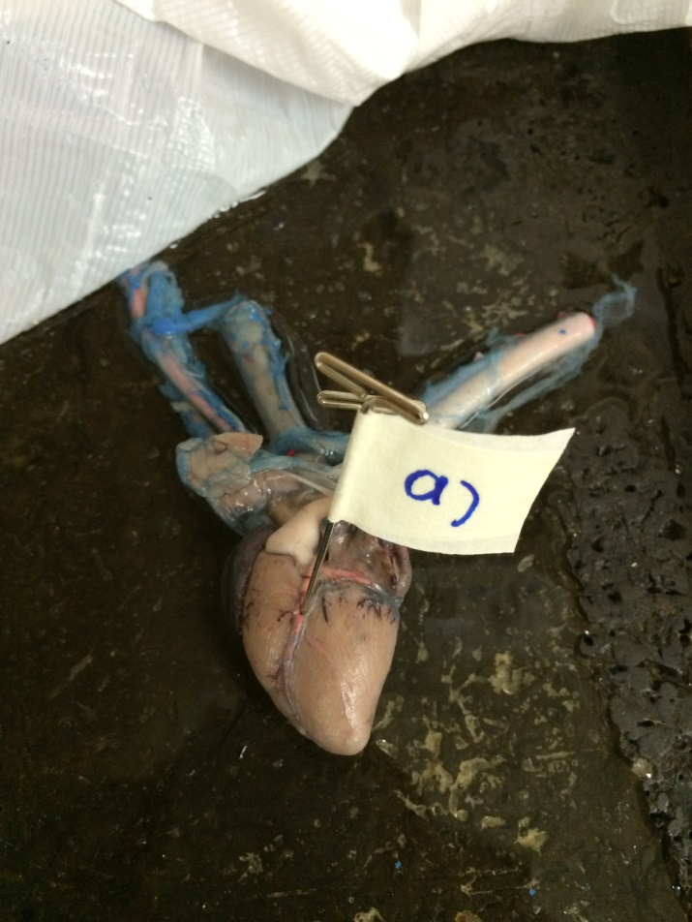 | - Which vessel is the pin pointing to?  - What is the common disease associated with this vessel?
2 | 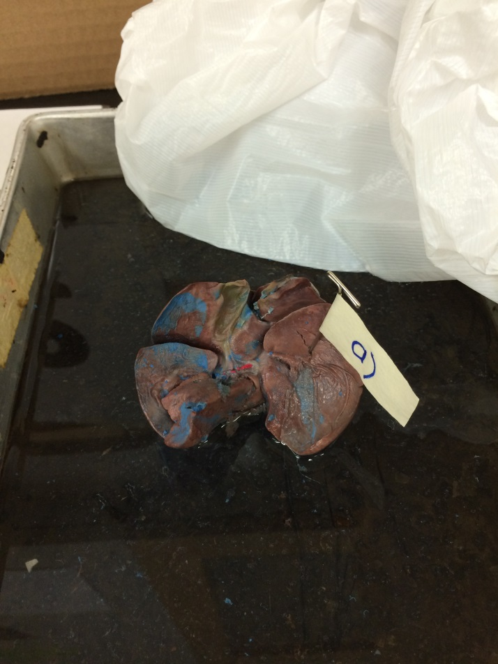 | Examine this organ.  - What is the name of this organ?  - What is its main digestive function?
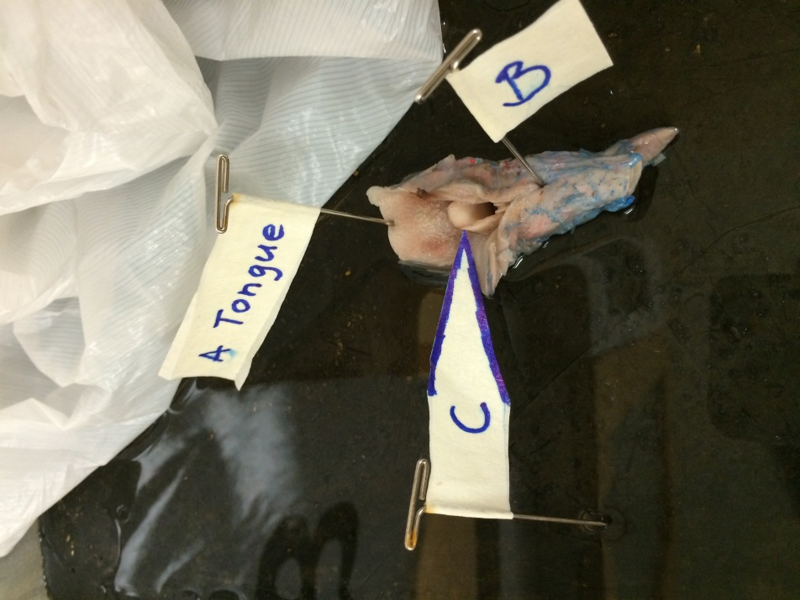  3 |  | Examine the organ. Identify the labelled parts.  - Name the part labelled B  - Name the part labelled C
5 | 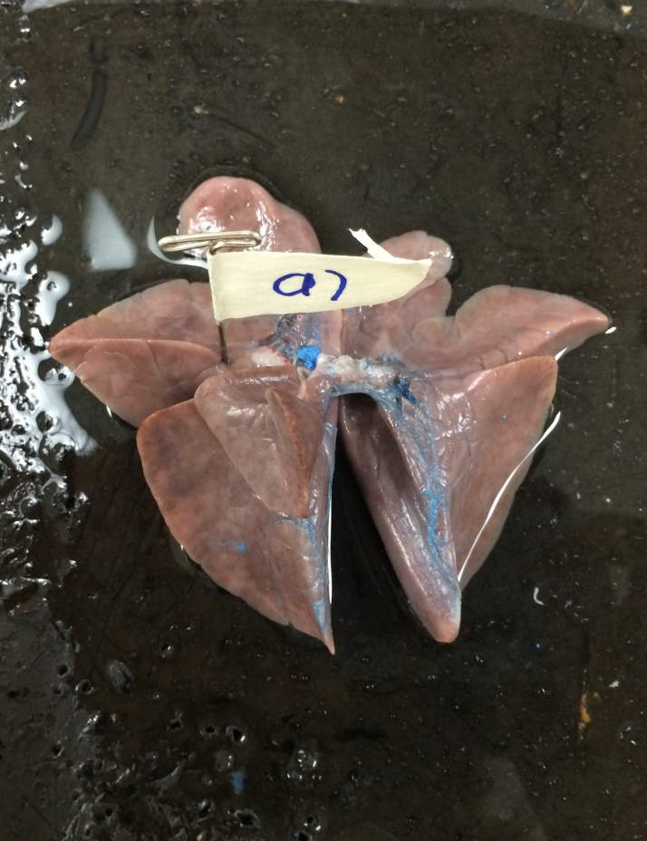 | Examine the lung.  - Which lung is it? The right or the left?  - How do you know?
6 | 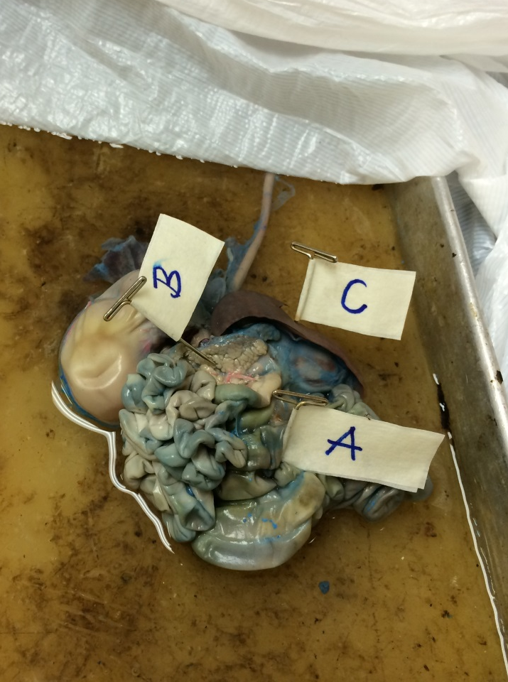 | Examine the organ.  - Name the part labelled A  - Name the part labelled B  - Name the part labelled C
9 |  | Examine the structure the pin is pointing to.  - Name the ring-shaped structure that controls the movement of food.  - What passes through it?
10 | 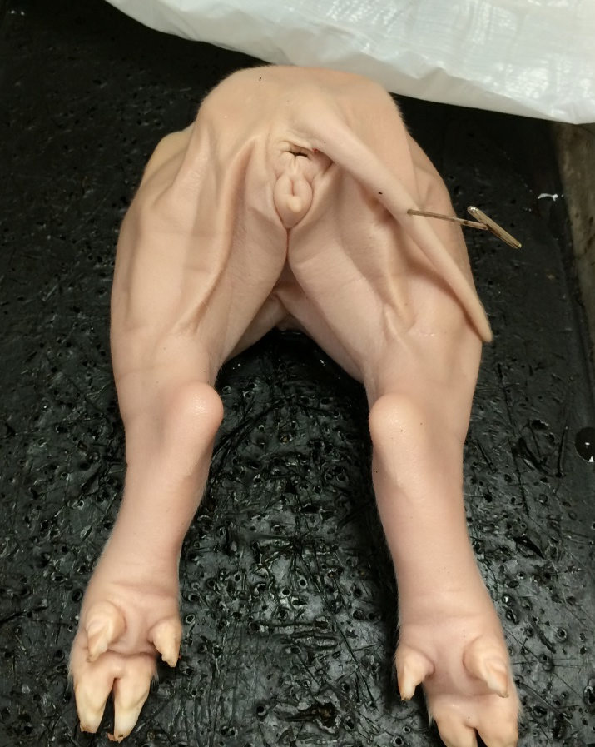 | - What is the gender of this fetal pig?  - What anatomical feature on the fetal pig did you use to determine the gender?
11 | 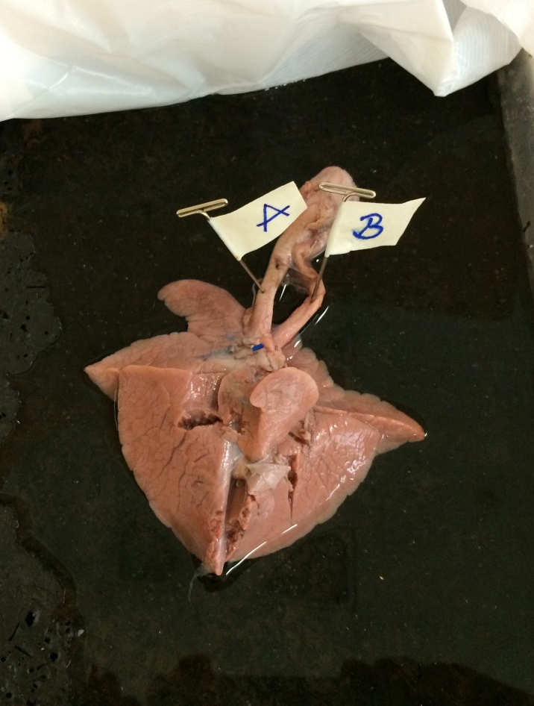 | Examine the specimen.  - What is the structure labelled A called?  - What is the structure labelled B called?
12 | 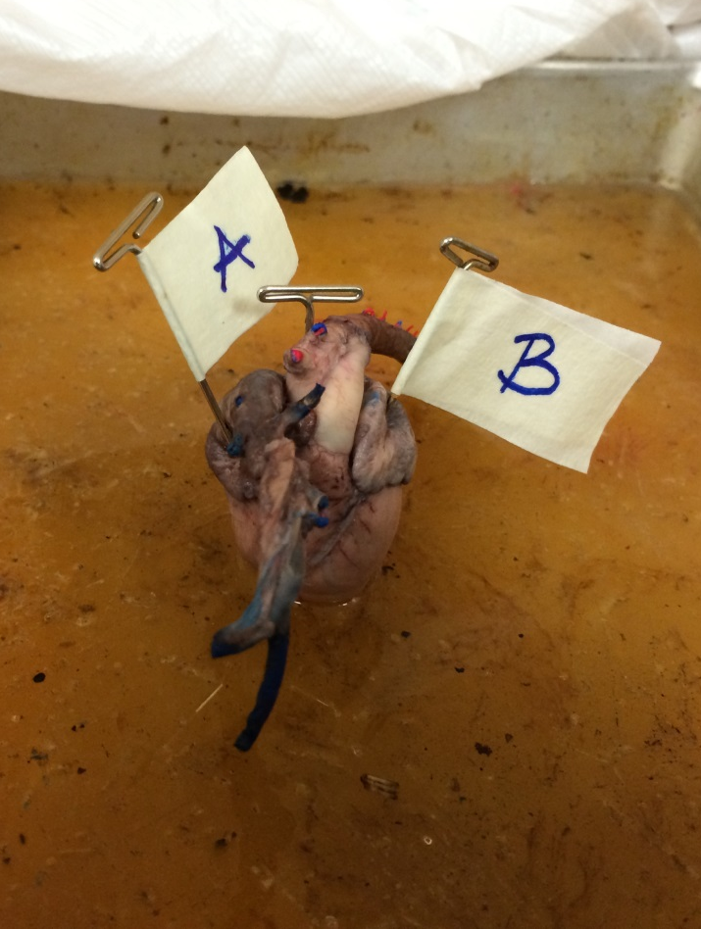 | Examine the model of the heart.  - Which letter represents the chamber of the heart in which blood returns from the lungs?  - Name this chamber.
15 | 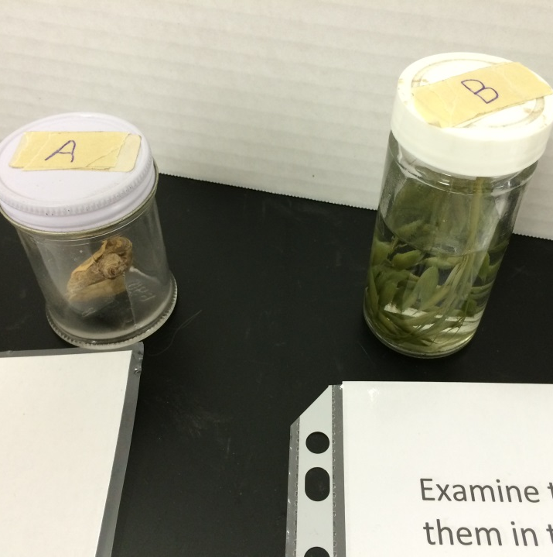 | Examine the specimens and put them in their respective kingdoms.  - Specimen A  - Specimen B

